**Assignment 6:**

**Question 1:**

“The definition of heap is that it is a complete binary tree that conforms to the heap order”

Compress the given sentence using Huffman encoding algorithm. You have to show complete steps like table, tree etc. After generating codes replace each character with their corresponding code.

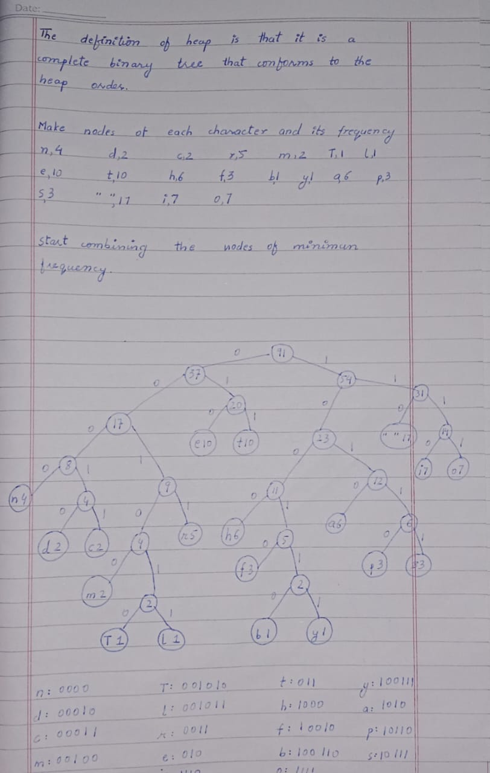

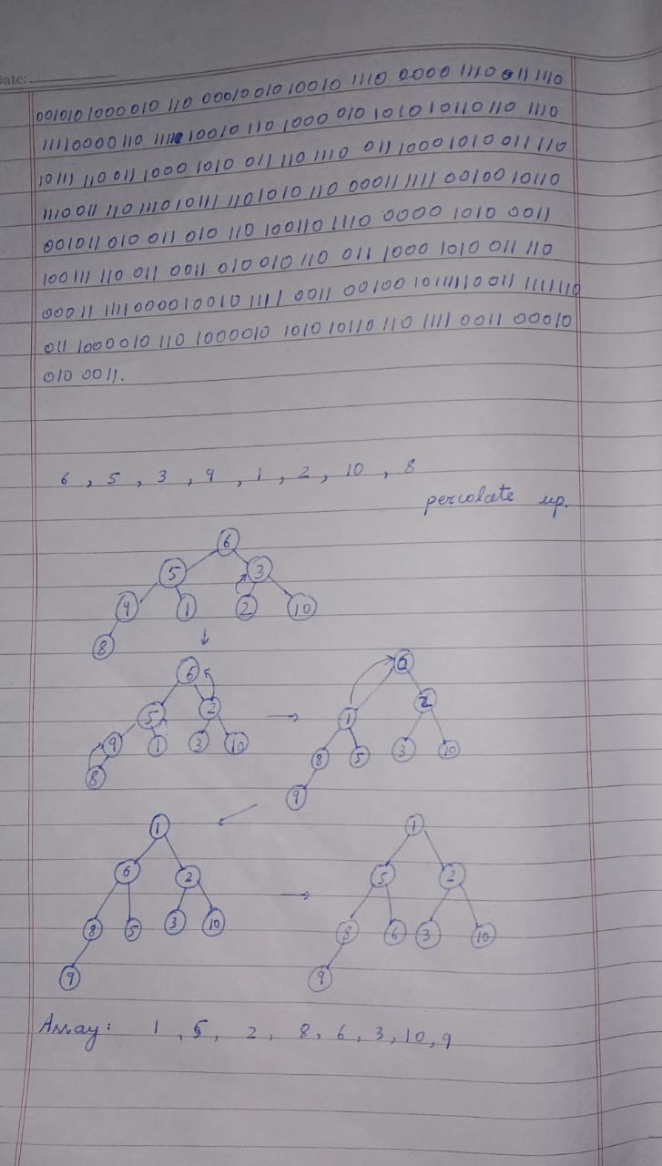

**Question 2:**

Heapify the elements of the following array (reading from left to right ) into a Min Heap and show that Min Heap contents in the form of array (as shown below) and tree. Original Array 6 5 3 9 1 2 10 8



**Question 3:**

623+-382/+*2↑3+ Convert the given postfix expression into an equivalent expression tree with the help of a stack. You have to show the complete steps.

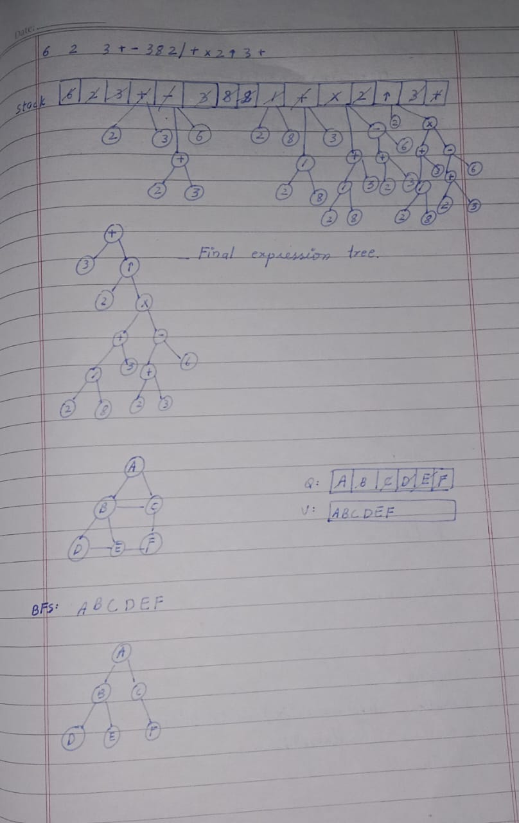

**Question 4:**

You should insert the objects from left (starting with ‘Dijkstra’) to right. For each bucket, indicate the total number collisions experienced when inserting the item(s) in the space to the left.

a. A separate chaining hash table with 10 buckets. Insert at the tail of each linked list.

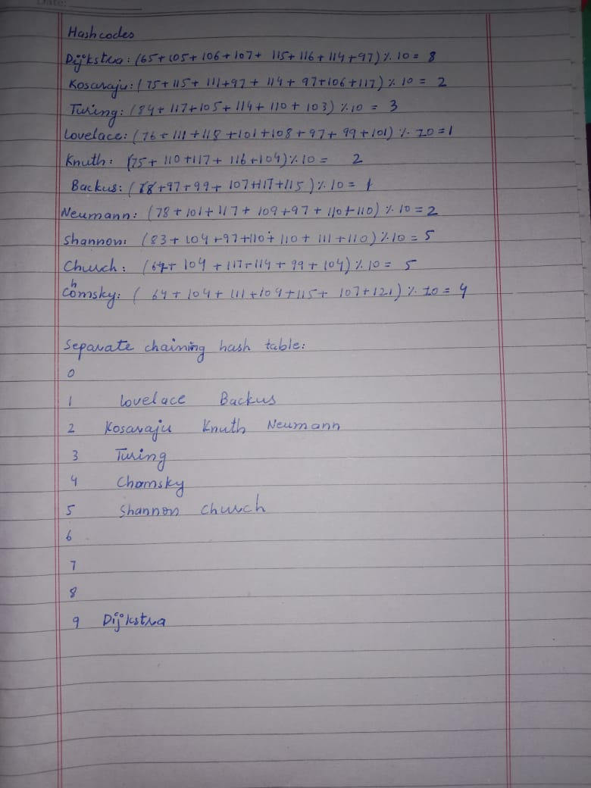

b. An open addressing hash table using linear probing with 17 buckets.

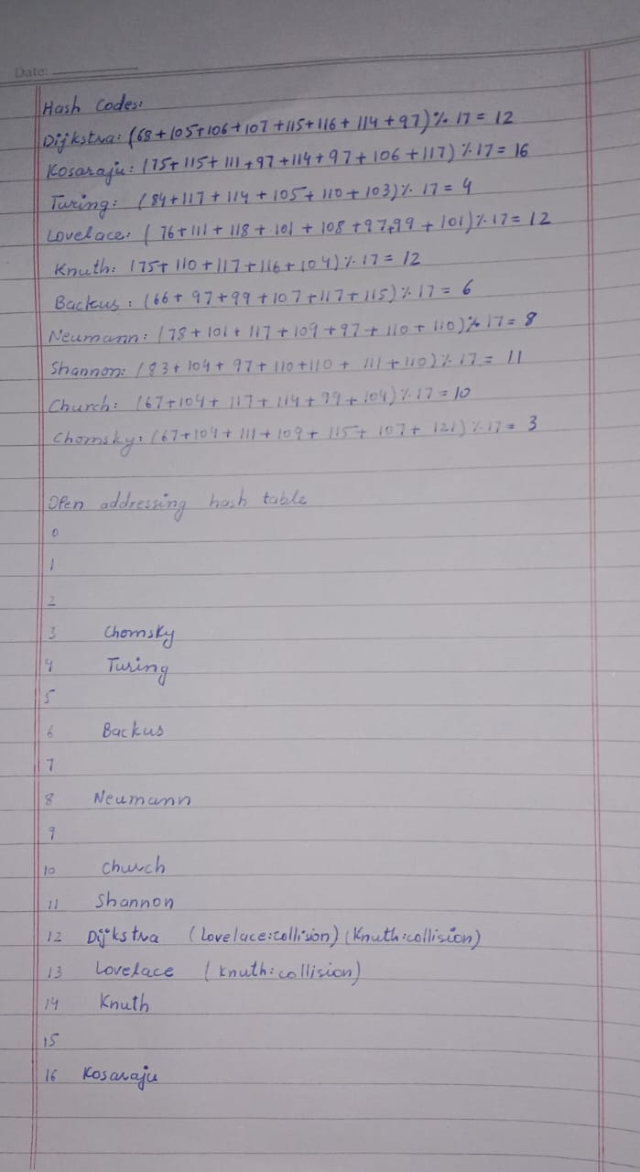

**Question 5:**

Apply BFS on the graph given below and show the resultant tree.

